**TIBCO Spotfire**

**Introduction**

**Documentation**

**Table Of Contents**

1. **Introduction…………………………………………… 2**
2. **Prerequisites……….……………………………….... 3**
3. **Usage Guides Location…………….…………….…. 4**
4. **Common Guides…………………………………….. 4 - 8**
   1. **General Spotfire…………..…………………………………. 4**
   2. **Microsoft Excel Data Source……………………………… 5 - 7**
   3. **Sharing Analysis…………..…………………………………. 7 - 8**
5. **TIBCO Spotfire Library…………….…………….…. 9**
6. **TIBCO Support………..…………….…………….…. 10 - 13**
   1. **Customer Support…….....…………………………………. 10 - 11**
   2. **Community Forum…………..……………………………… 12 - 13**
7. **References……………..…………….…………….…. 14**
   * **TIBCO Spotfire Subscription Models**
   * **Databases At data.gov.sg**
   * **Official TIBCO Spotfire Documentation**
   * **TIBCO Customer Support**
   * **TIBCO Community Forum**

**1. Introduction**

TIBCO Spotfire is a platform that allows users to **create visualizations with a provided data source**. It is one of the many services offered at TIBCO Cloud. To name a few of their services, below is an image of their most featured services. To view more of their services you can their website [here](https://www.tibco.com/).

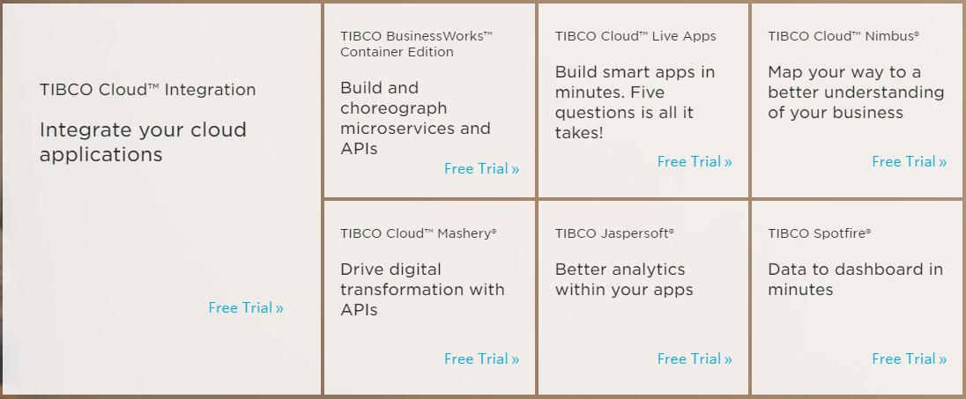

There are **two versions of spotfire**, a web client and a desktop application. Both versions are available with an Analyst subscription. Only the desktop application is available with an Analyst subscription, and it is the superior version of the two. To view their subscription models, click the link [here](https://www.tibco.com/products/tibco-spotfire/editions-pricing).

**TIBCO Spotfire is a paid subscription service** provided at the TIBCO Cloud website. Although it is a paid subscription to use their service, a request for a 30-day trial version is an option as well. Though not supported for long term use.

**2. Prerequisites**

When using TIBCO Spotfire, it is important to have a **TIBCO Cloud account created, with a TIBCO Spotfire Analyst Subscription**. You must also have a **sample data source** to test with TIBCO Spotfire.

Depending on your Spotfire version, web client or desktop application, TIBCO Spotfire will only accept specific file formats and/or databases as a data source. As of writing this documentation, the **accepted file formats** for data sources are as follows:

**For Web Client and Desktop Application:**

Microsoft Excel Workbooks (**.xlsx, .xls**), Microsoft Excel Binary Workbooks (**.xlsb**), Microsoft Excel Macro-Enabled Workbooks (**.xlsm**), comma separated values files (**.csv**), text files (**.txt**), logfiles (**.log**), TIBCO Spotfire Text Data Format files (**.stdf**), and TIBCO Spotfire Binary Data Format files (**.sbdf**). You can also open locally saved TIBCO Spotfire analysis files (**.dxp**), but you will not create a new analysis; instead an existing analysis will be opened.

**For Desktop Application:**

Amazon Redshift, Apache Drill, Apache Spark SQL, Attivio, Cloudera Hive, Cloudera Impala, Dremio, Google Analytics, Google BigQuery, Hortonworks, IBM DB2, IBM Netezza, **Microsoft SQL Server**, Microsoft SQL Server Analysis Services, OData, Oracle, Oracle Essbase, Oracle MySql, Pivotal Greenplum, Pivotal HAWQ, PostgreSQL, Salesforce, SAP BW, SAP HANA, Snowflake, Teradata, Teradata Aster, TIBCO Cloud Live Apps, TIBCO ComputeDB, TIBCO Data Virtualization, TIBCO Spotfire Data Streams, Vertica.

**If you do not have a sample data source, you may refer to this link** [here](https://data.gov.sg/). This link leads to data.gov.sg, where many free data sources are provided. These data sources can be used for testing TIBCO Spotfire.

Alternatively, you may use the “Database To Excel App” developed for this project. Using the applications will enable the conversion of a database into an Excel sheet file. Refer to the “Database To Excel App (Windows Forms)” documentation for more details on how to use.

**3. Usage Guides Location**

As TIBCO Spotfire can be separated into two versions, I will be documenting each version on two different documentation reports.

The Web Client version can be read in the “TIBCO Spotfire Web Client Documentation”, while the Desktop Application can be read in the “TIBCO Spotfire Desktop Application Documentation”.

Additionally, a “TIBCO Spotfire Extension Research” documentation can be read to learn more about TIBCO Spotfire, the difference between the Desktop and Web Client version, and how to setup more features into your Spotfire Desktop version.

In the remaining portion of this documentation, I will be sharing some common guides for both versions, and where to seek help for anything TIBCO related.

**4. Common Guides**

**4.1 General Spotfire**

Entering TIBCO Spotfire, you are able to create visualisations like graphs and pie charts to depict meaningful visuals to allow users to spot trends and relations by looking at the images. To learn how to use TIBCO Spotfire, below is an image of how TIBCO Spotfire works

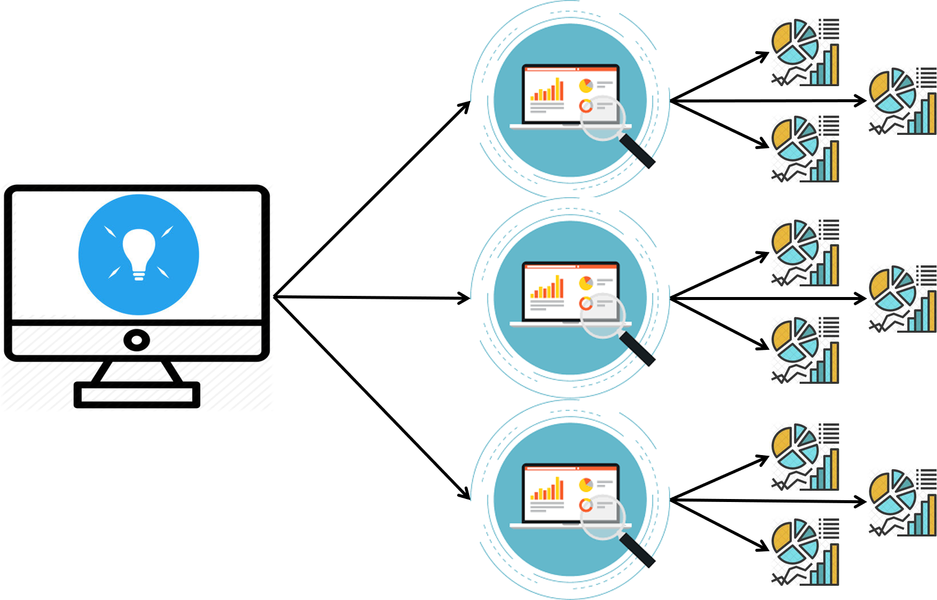

With TIBCO Spotfire as the root, you can create multiple Analysis. In each Analysis, you can create multiple pages of visualisations. And in each page of visuals, contains visualisations.

This concept is similar to Microsoft Excel, where Excel contains workbooks, containing worksheets, containing data inside.

**4.2 Microsoft Excel Data Source**

At the time of handling with TIBCO Spotfire, I have been using Microsoft Excel data sources. If you are using a Microsoft Excel as a data source, you may need to make some **data preparation before loading it**.

Before loading a Microsoft Excel file into an analysis, it is important that the data spreadsheet is **free from irrelevant information and has a good structure to prevent misinterpretation**. Possible actions that can be done before loading data are **removing contextual information and combining columns into one**.

The tabular format of the data in an Excel spreadsheet will be represented as a data table in your analysis. The first row with data in the spreadsheet will be interpreted as names of the data columns in the table, and the following rows will be interpreted as data rows.

**Remove contextual information**

The following illustration shows an example spreadsheet containing some contextual information above the actual data table. This will cause misinterpretation of the data.

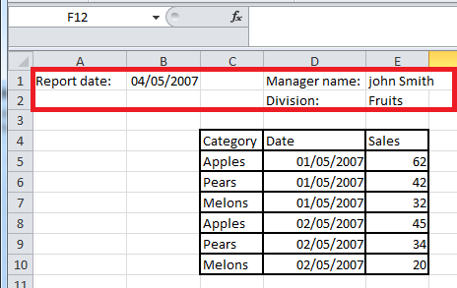

**Remove any contextual information before loading the data, to get good results**. In the sheet below, there is no contextual information before the actual data set, so it will therefore be interpreted correctly.

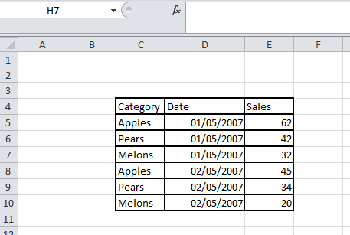

**Combine columns**

The data can be organized in different ways, short/wide or tall/skinny, but still contain the same information. Often, it is easier to visualize **data organized in a tall/skinny format**. You can transform your data in Spotfire by [unpivoting columns](http://docs.spotfire.cloud.tibco.com/spotfire/GUID-FA9A01DA-A6B7-4E3C-8A91-93B323716180.html), but if you are more comfortable with doing this work in Excel, it can also be done before uploading the data to Spotfire.

For example, the following Excel spreadsheet contains the numbers of sold entrance tickets for five different desks. The data is organized in a short/wide format, that is, the spreadsheet has many columns with similar data.

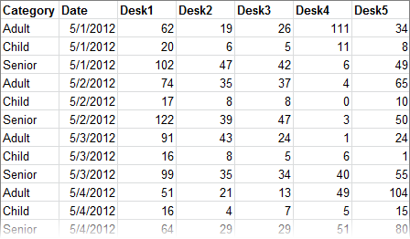

In the spreadsheet below, the same data is organized in the tall/skinny format. **The values from the desks have been combined in one column.**

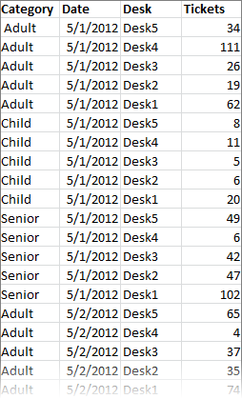

It is best practice to remove any contextual information, and create a tall/skinny format when using the data source for TIBCO Spotfire.

To provide self convenience in using an Excel Sheet for TIBCO Spotfire, I have created an application that allows the conversion of a database to an Excel Sheet. As of creating this project and documentation, there are no available convertors online, hence, you may use this application to convert your database into an Excel Sheet. Please refer to the documentation of the application to understand how to use it.

**4.3 Sharing Analysis**

Reached post-creation, sharing the project is essential as to allow collaboration, and to be properly displayed in web pages through the HTML iframe tag.

To display the project into a website, click on the “File > Share > Copy link…”. A pop-up will then appear that will display two links, “Link to analysis” and “HTML embed code”.

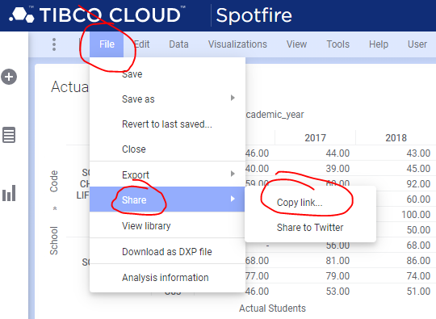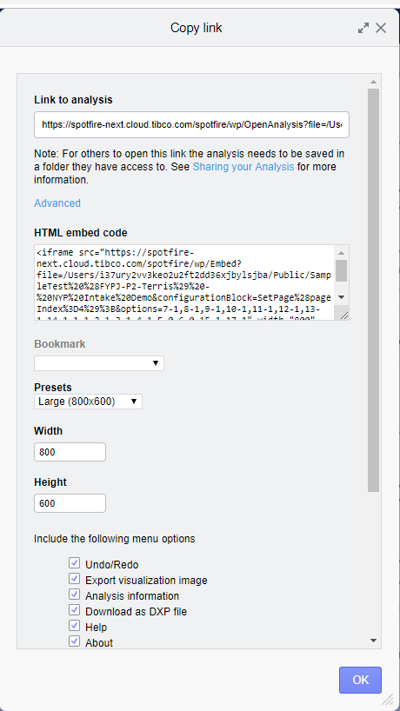

Both links provided is usabled inside the iframe tag. However, only the HTML embed code has the settings to set the controls such as edit mode. The con of using the HTML embed code is that a UI bug will pop up whenever loaded into a website.

My recommendation is to use the “Link to Analysis”, then change the options code numbers to the settings from the “HTML embed code”.

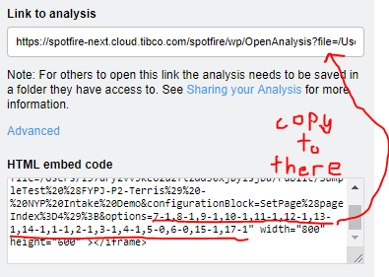

With best practice, it is professional to purchase additional subscriptions to view and edit the analysis for large corporate use.

**5. TIBCO Spotfire Library**

After creating your analysis, it will be saved into your TIBCO Spotfire Library. To access it, simply log into any of the TIBCO Spotfire versions. At the top left, click on “File > View library”. This is the most common way of viewing the library.

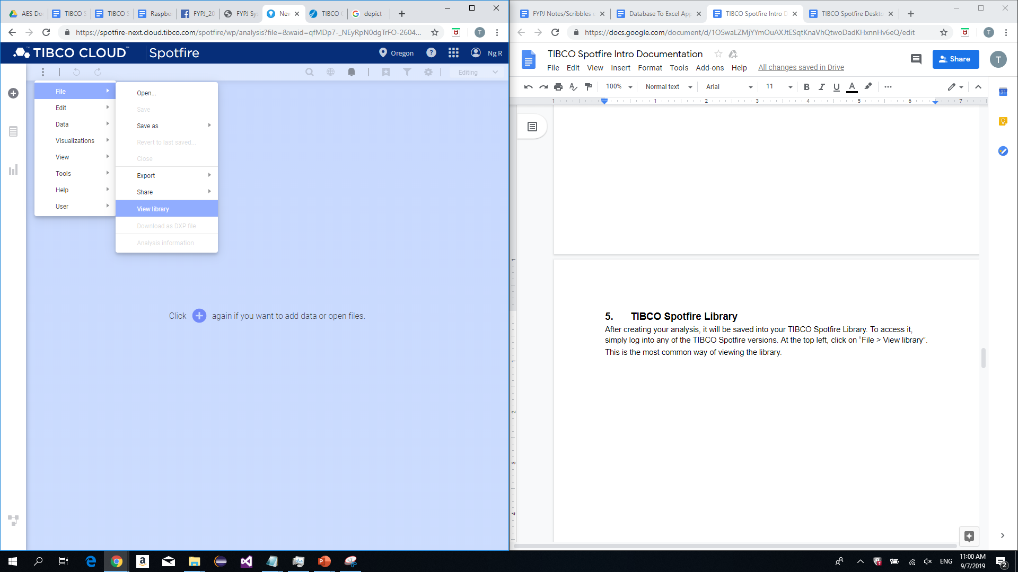

Regardless of version, your default browser will open with your TIBCO Spotfire Library webpage. This page is where you can manage all your TIBCO Spotfire related documents. Documents such as Analysis, stored databases (If any), shared Analysis, and resources.

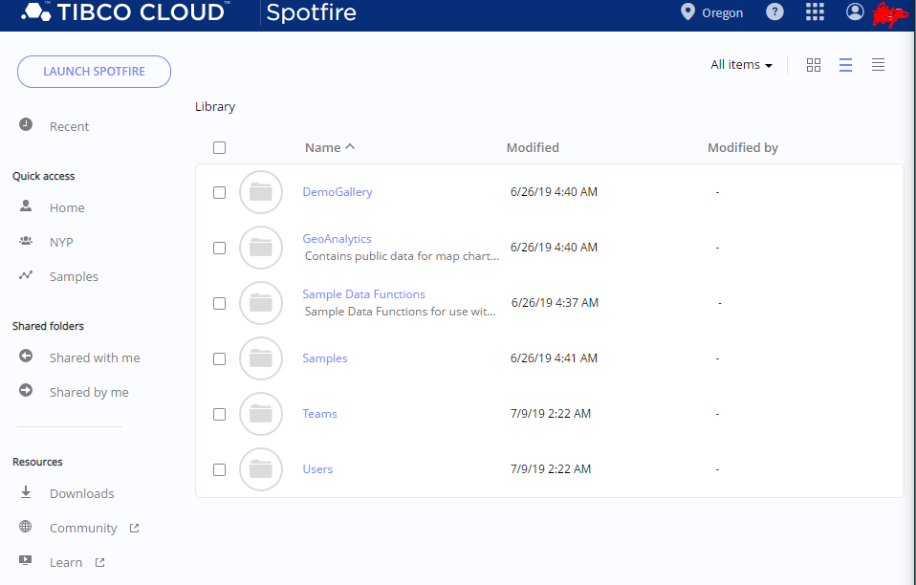

In resources will contain the Spotfire Desktop App installer download, link to the community forum, and a link to additional education for Spotfire usage. I will share the Spotfire Desktop installer in the “TIBCO Spotfire Desktop Application Documentation” report.

.

**6. TIBCO Support**

When using TIBCO Spotfire, you may come across with enquires or problems that are not easily searchable via Google. In this section of the documentation, I will be sharing two different web areas to obtain information about any TIBCO products.

The two web areas are provided are both platforms provided by TIBCO. They are their customer support, and a community forum.

**6.1 Customer Support**

By accessing the link [here](https://formvine.tibco.com/fv/r/9526489240/3346?_ga=1.242224834.1166307550.1415094790), you may send a customer support ticket. Depending on traffic, customer support will send a reply to your provided email as early as the next day.

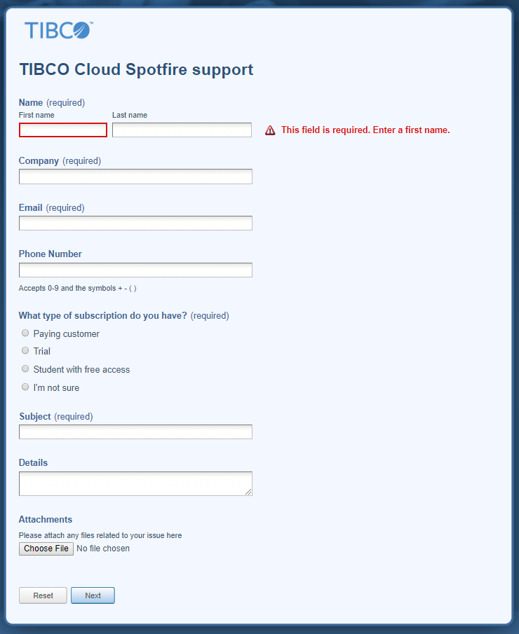

Depending on the question, customer support will also try their best to answer your query to the point. As an example, below is an image of a customer support query I sent during my exploration of TIBCO Spotfire.

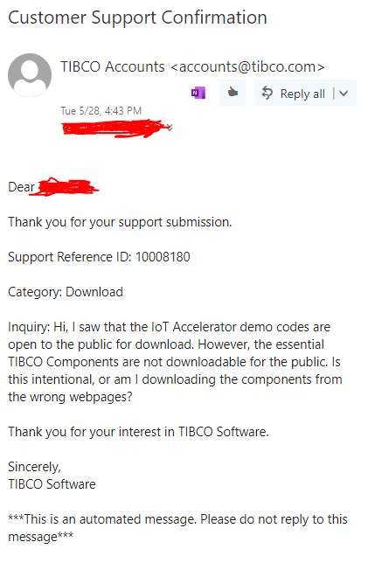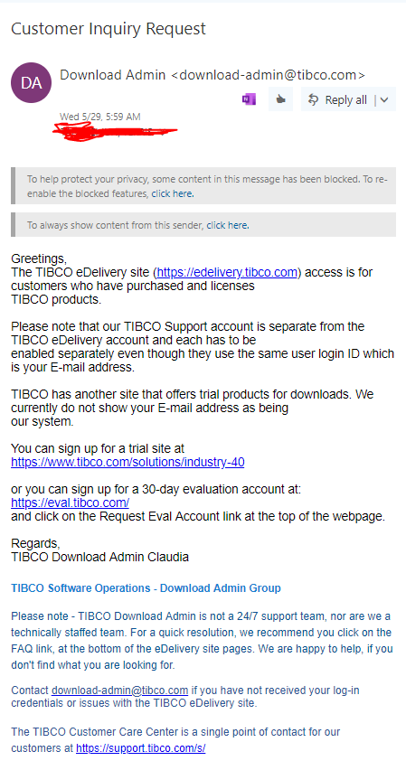

From the example, TIBCO Customer Support will give a detailed answer to any technical difficulties in understanding their business model, and how to download their software.

**6.2 Community Forum**

By accessing the link [here](https://community.tibco.com/products/spotfire/), you may view the TIBCO Community Forum. You must login to your TIBCO account to post a question in the forum.

Below is an image of the website:

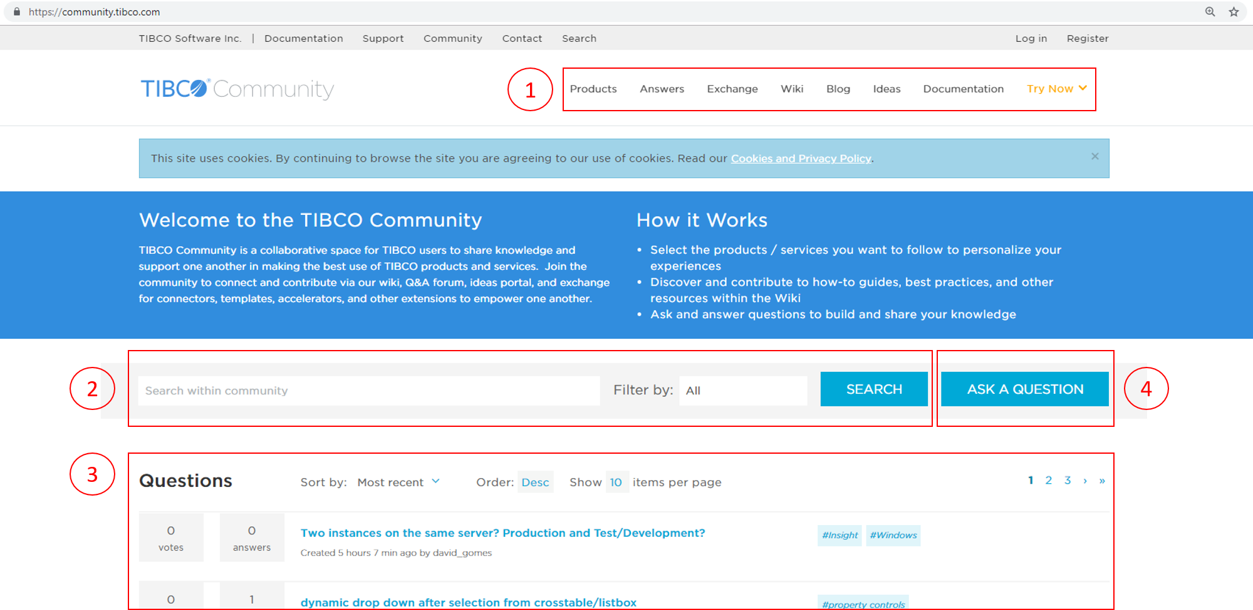

**Section 1:**

The navigation tab used to navigate the community forum website. You can view their products, posts, wiki, blog, ideas, and documentations to seek help from any of these tabs.

**Section 2 & 3:**

The search bar is used to search for answers regarding anything TIBCO. The Questions will be the list of post results from your search. You can see the number of votes, and the number of answers for the question. It also displays the date created, and tags to narrow down the category of the question.

**Section 4:**

The button when clicked will direct you to creating a post. You must provide a question, description, product relevance, any images, and answer a captcha when creating a post.

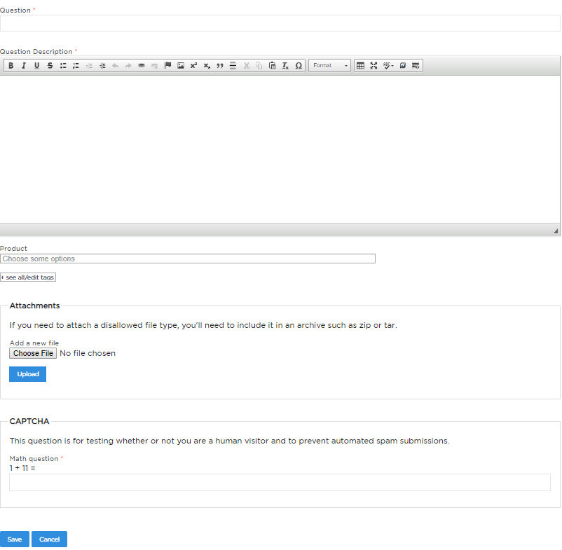

**Conclusion:**

The TIBCO Community Forum, in general, is fairly active and most questions are answered by TIBCO staff as they have the most relevant experience. The platform can find most of your TIBCO related questions and problems.

**7. References**

TIBCO Spotfire Subscription Models:

<https://www.tibco.com/products/tibco-spotfire/editions-pricing>

Databases At data.gov.sg:

<https://data.gov.sg/>

Official TIBCO Spotfire Documentation:

<http://docs.spotfire.cloud.tibco.com/spotfire/index.html>

TIBCO Customer Support:

<https://formvine.tibco.com/fv/r/9526489240/3346?_ga=1.242224834.1166307550.1415094790>

TIBCO Community Forum:

<https://community.tibco.com/products/spotfire/>